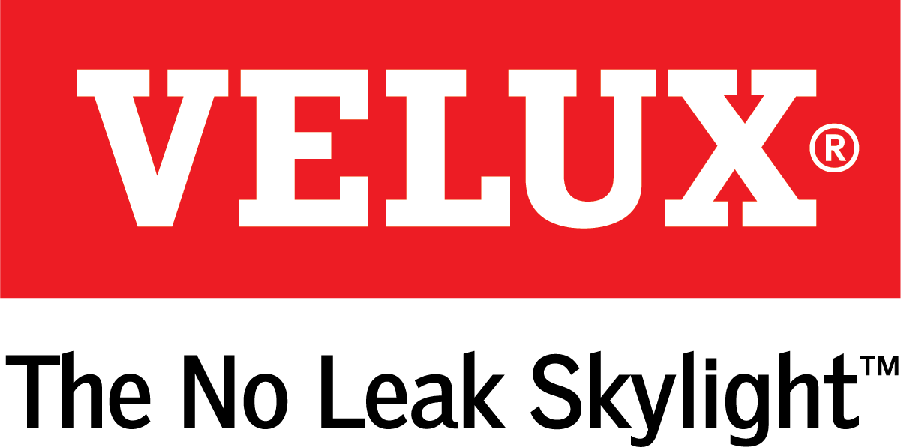
Media Contacts:
Dana Haydock
704-926-1301
dhaydock@wrayward.com

Ashley Moran
704-926-1376
amoran@wrayward.com

VELUX® AMERICA SHOWCASES COMMERCIAL SKYLIGHT PRODUCTS

AT INTERNATIONAL BUILDERS’ SHOW

Learn More at IBS Booth W3117

ORLANDO, Fl., Jan. 9-11, 2018 – For commercial builders and developers who are looking for ways to incorporate energy efficiency in to their building designs, VELUX America can help. VELUX offers commercial daylighting options that allow building operators to keep the lights off longer.

VELUX Dynamic Dome Skylights
VELUX Dynamic Dome commercial skylights combine architectural elegance with increased light harvesting capabilities to bring more natural light inside warehouse-style buildings for a longer amount of time resulting in savings on electrical lighting costs.
The geometric pattern of ridges and ribs improves light harvesting at low angles so more light is captured and transmitted to the interior of the building for a longer portion of the day.
“In product simulations, Dynamic Dome skylights harvested up to 56 more minutes of additional sunlight per day, for a potential yearly lighting savings of up to 340 hours,” said Ross Vandermark, national product manager for VELUX America.
While the design of the Dynamic Dome skylights allow more sunlight in, it also keeps the other elements out with a fail-safe proprietary wicking system and secure thermal seal. For more information and size configurations, visit www.veluxusa.com/dynamic-dome.

VELUX Modular Skylights
VELUX America’s line of Modular Skylights (VMS), available in six configurations, make it simple to transform commercial spaces using daylight and fresh air without the headaches typically associated with atrium-style ceiling glazing.
The modular system, designed in cooperation with architects from London-based Foster + Partners, integrates ventilation and sunscreening components into a skylight design for a modular skylight concept that offers ease of installation and versatility.
“The modular nature of the product makes it easy to integrate into a variety of architectural styles, roof configurations and interior lighting needs,” said Vandermark. “It’s a plug and play solution that saves time while providing maximum benefit to the end user.”
The VMS system is a predesigned, pre-engineered system that eliminates the need for worksite caulking, puttying, welding, soldering or glass cutting. To learn more, visit www.veluxusa.com/vms.
# # #

VELUX is the world leader in skylights and roof windows and is one of the strongest brands in the global building materials sector. VELUX America products are available nationwide through home centers, building material suppliers, lumberyards, and independent door, window, or roofing retailers. Consumers can locate local suppliers and installers and access information on skylight selection and the benefits of bringing more natural light and fresh air into the home by visiting www.veluxusa.com or www.whyskylights.com. VELUX skylights are made in America in Greenwood, South Carolina.

